**User Assignment -1**

**Problem Statement:**

**CREATING FARE SCHEMA**

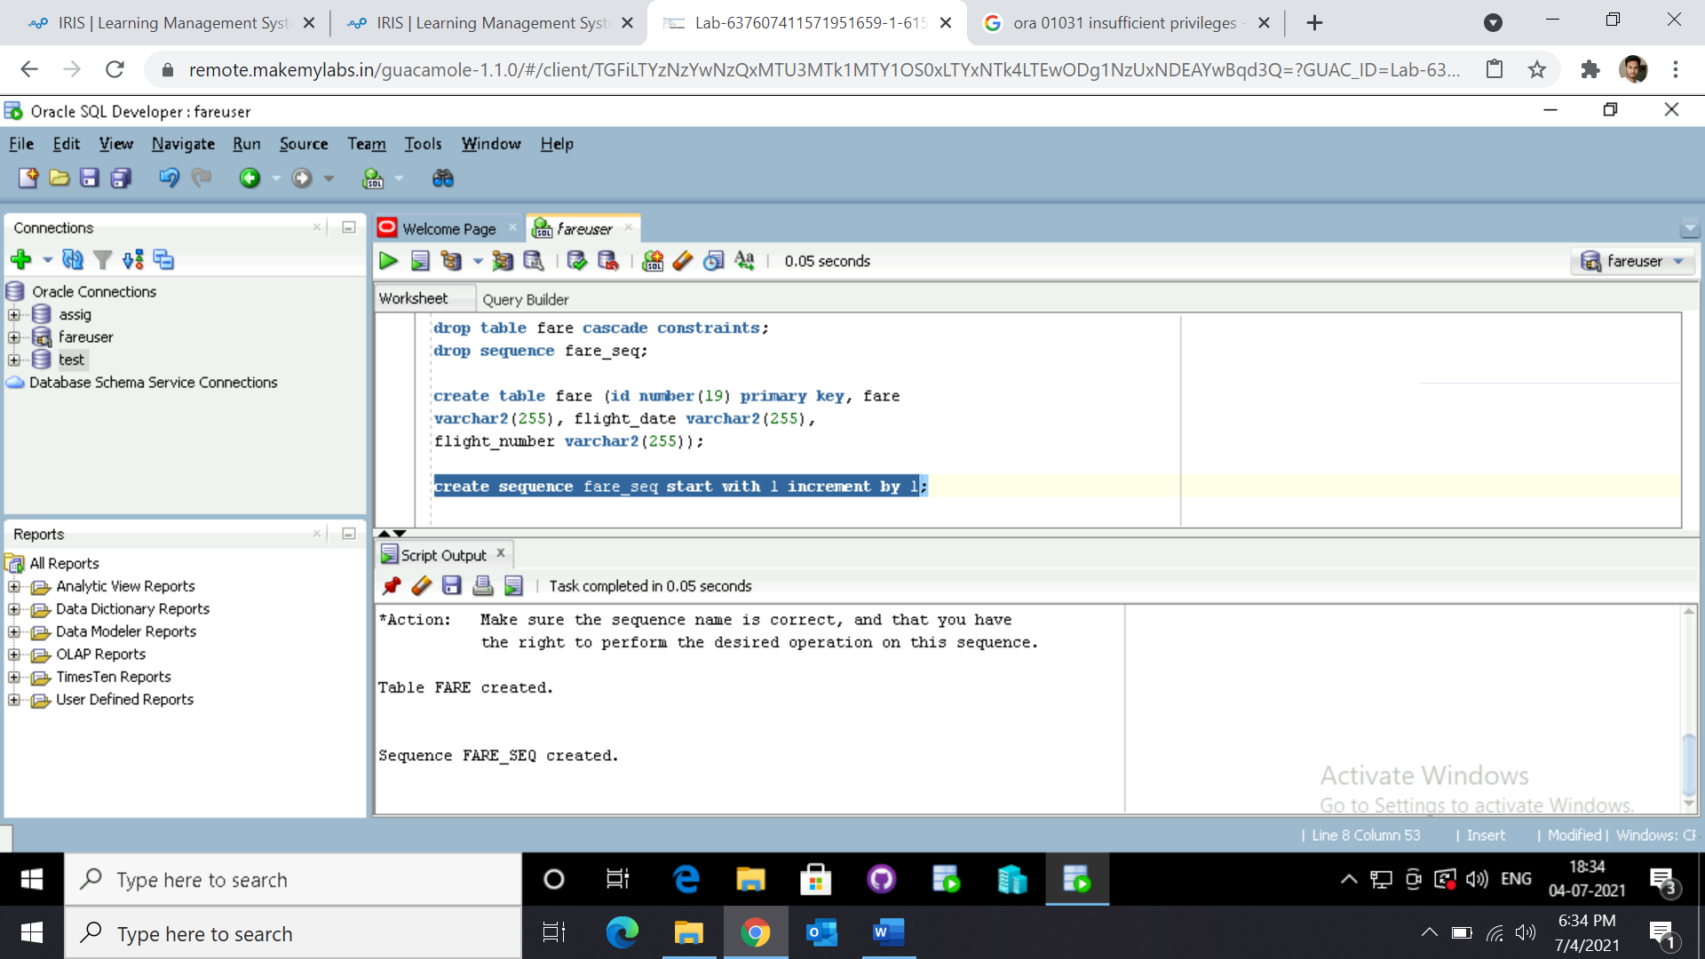

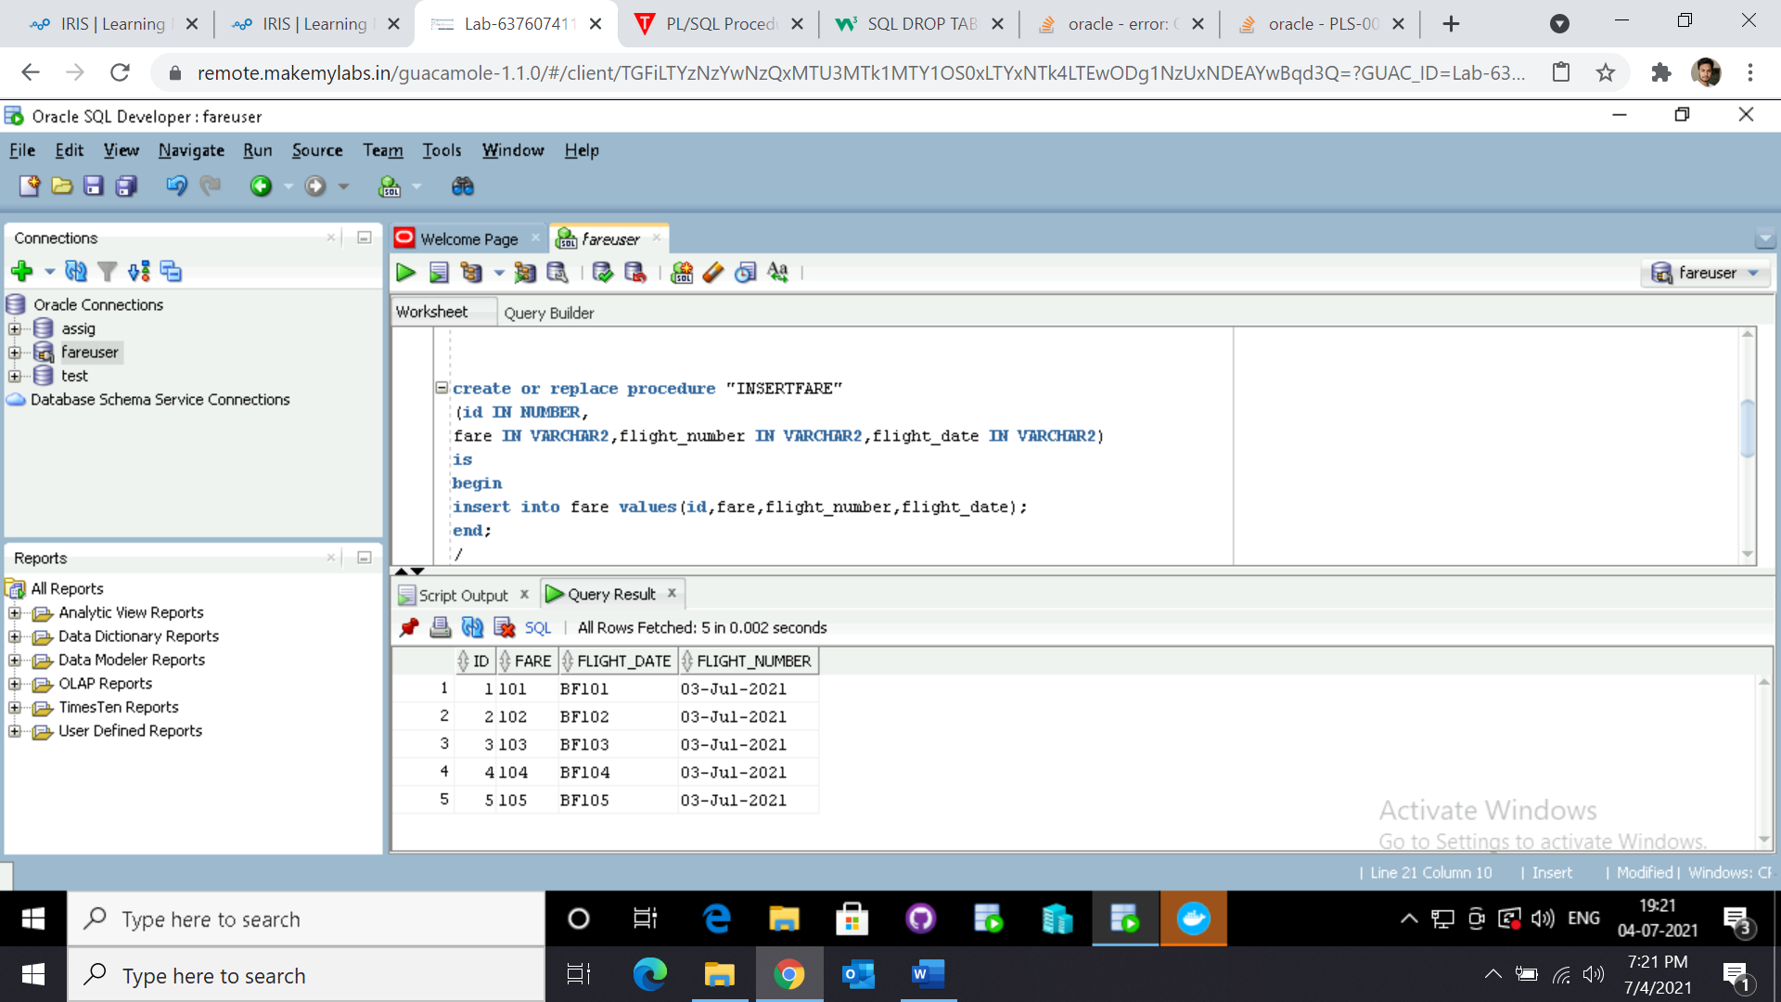

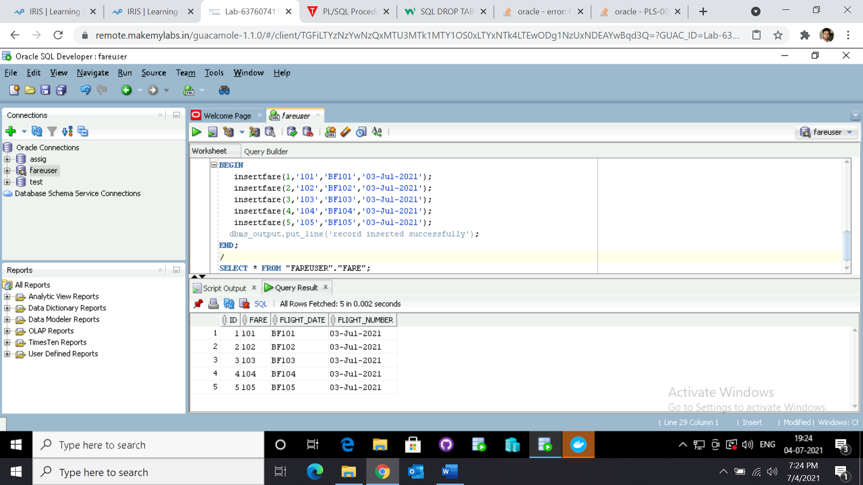

**CREATING SEARCH SCHEMA**

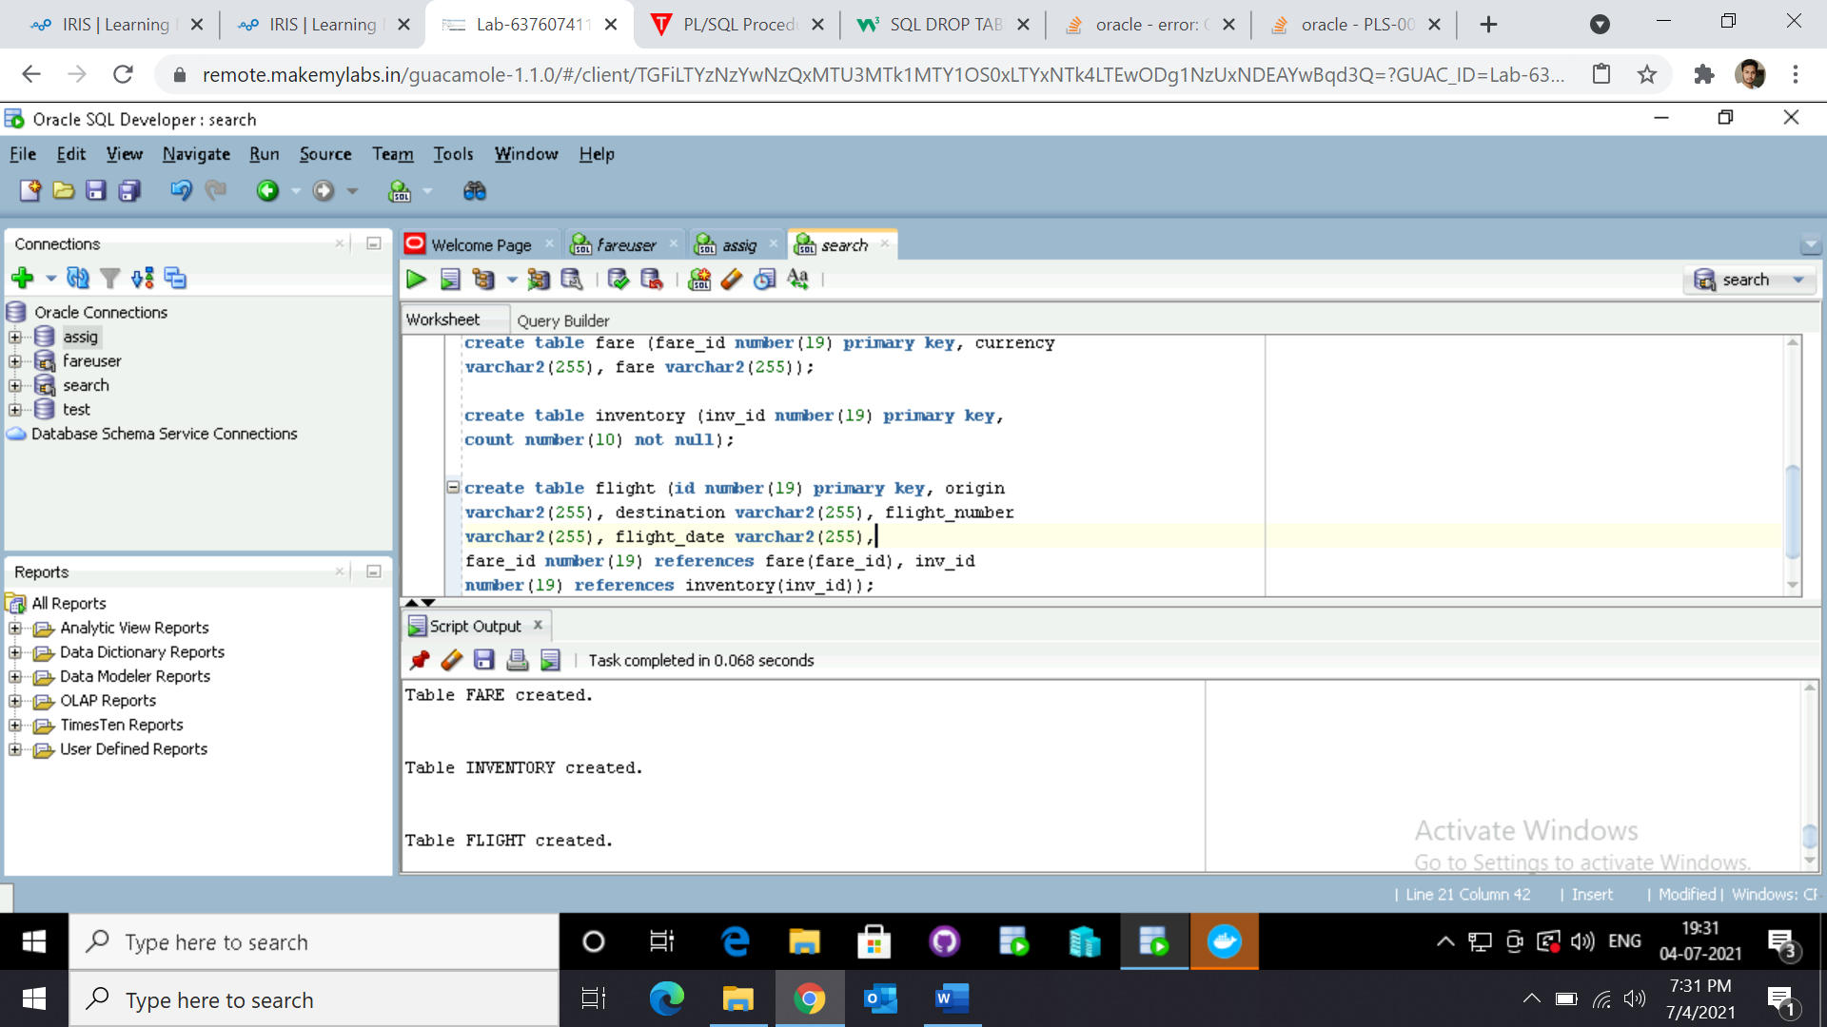

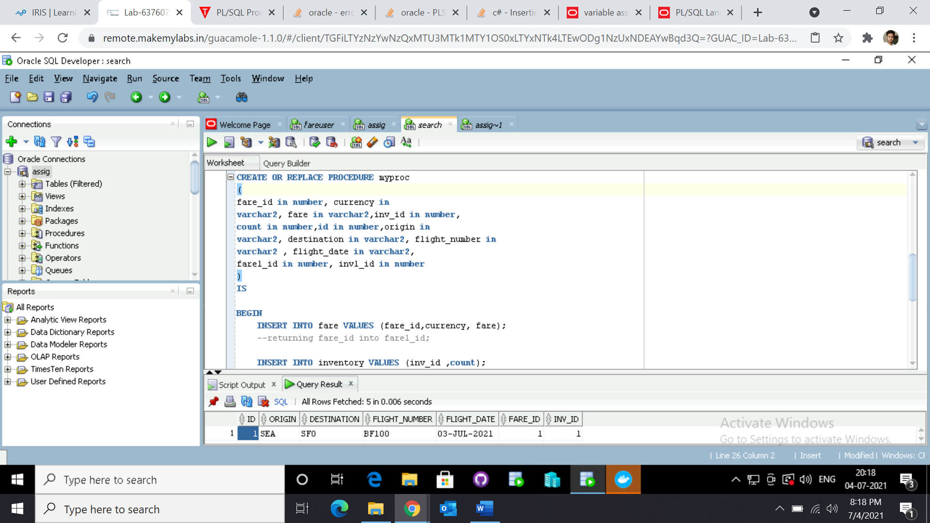

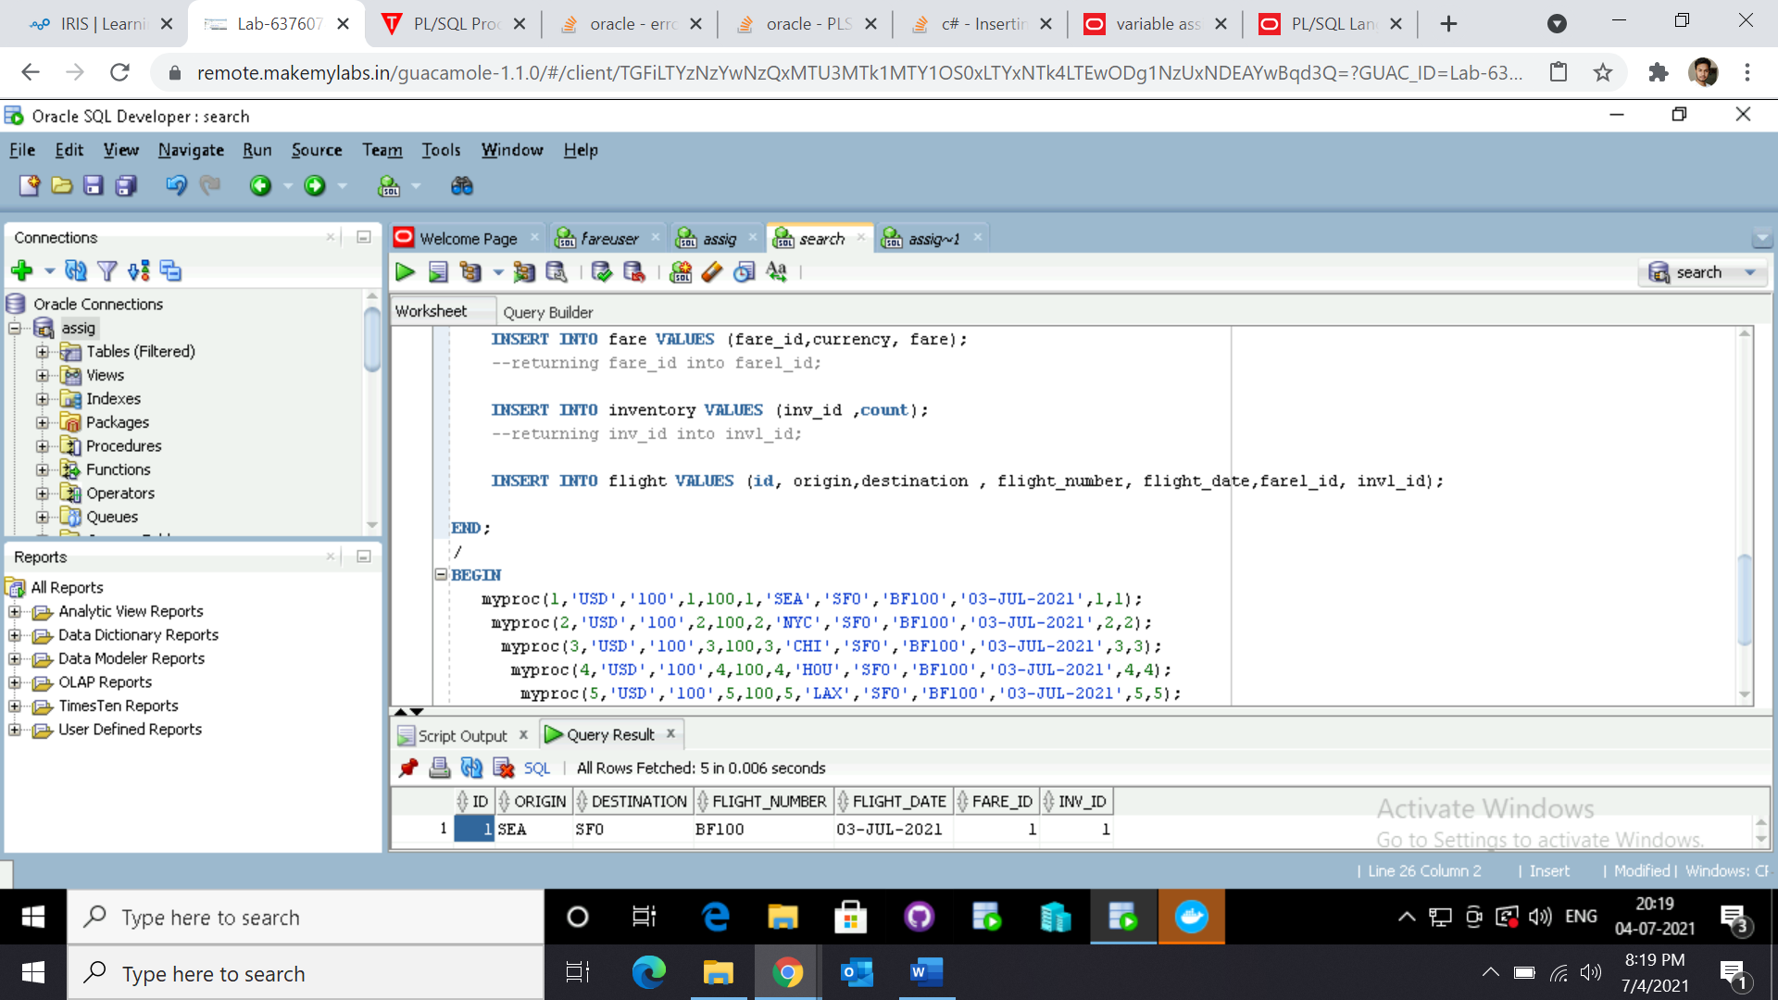

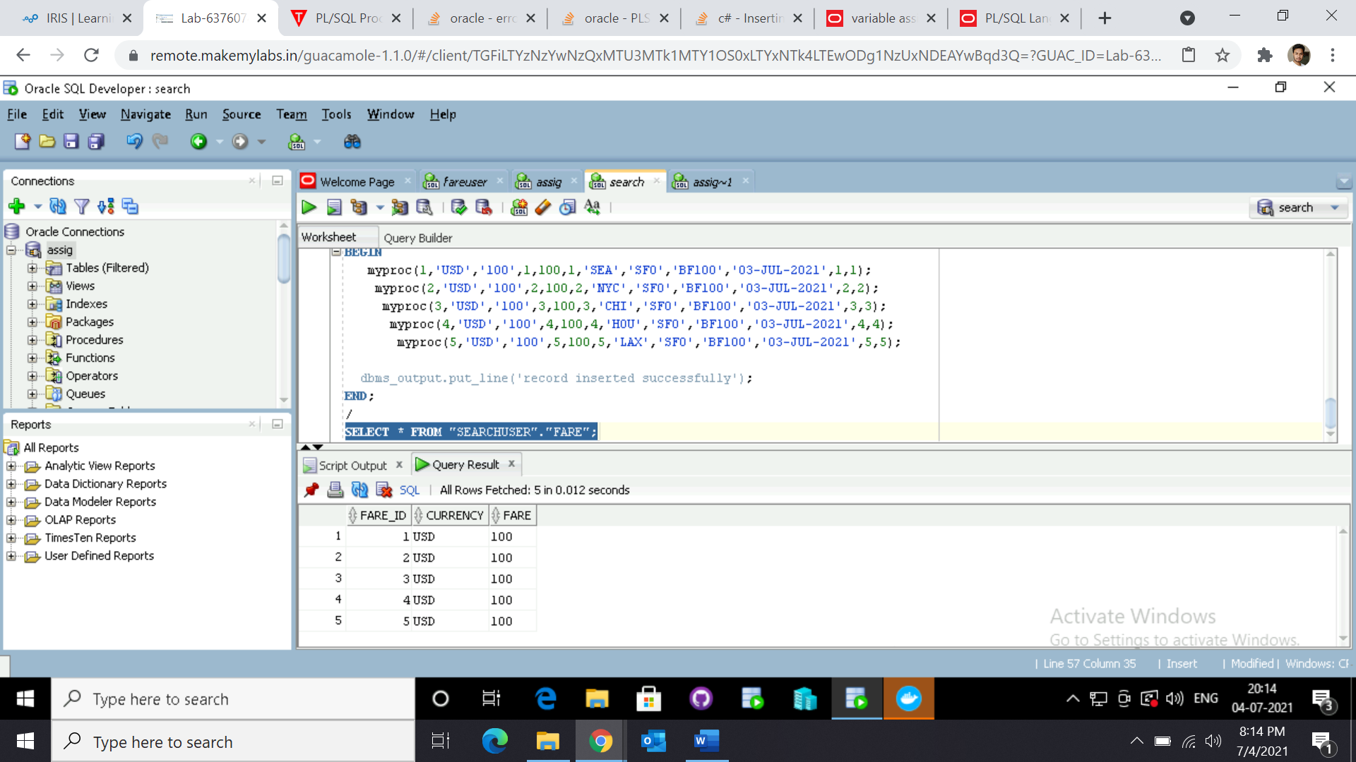

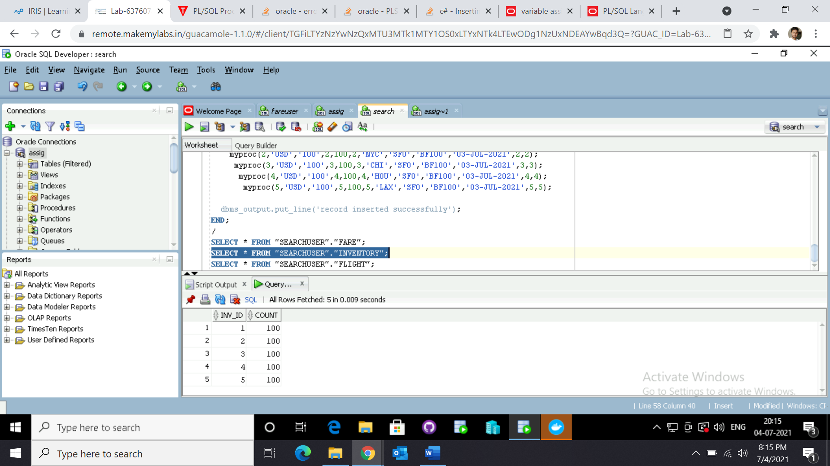

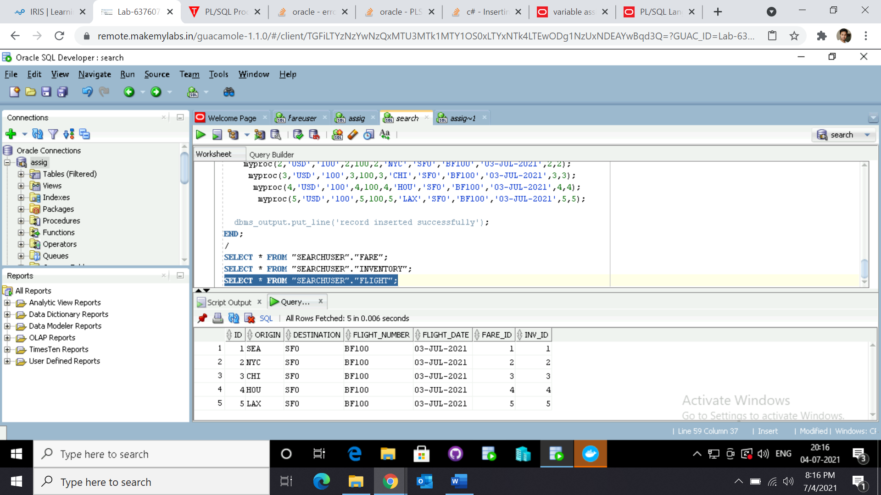

**User Assignment 2:**

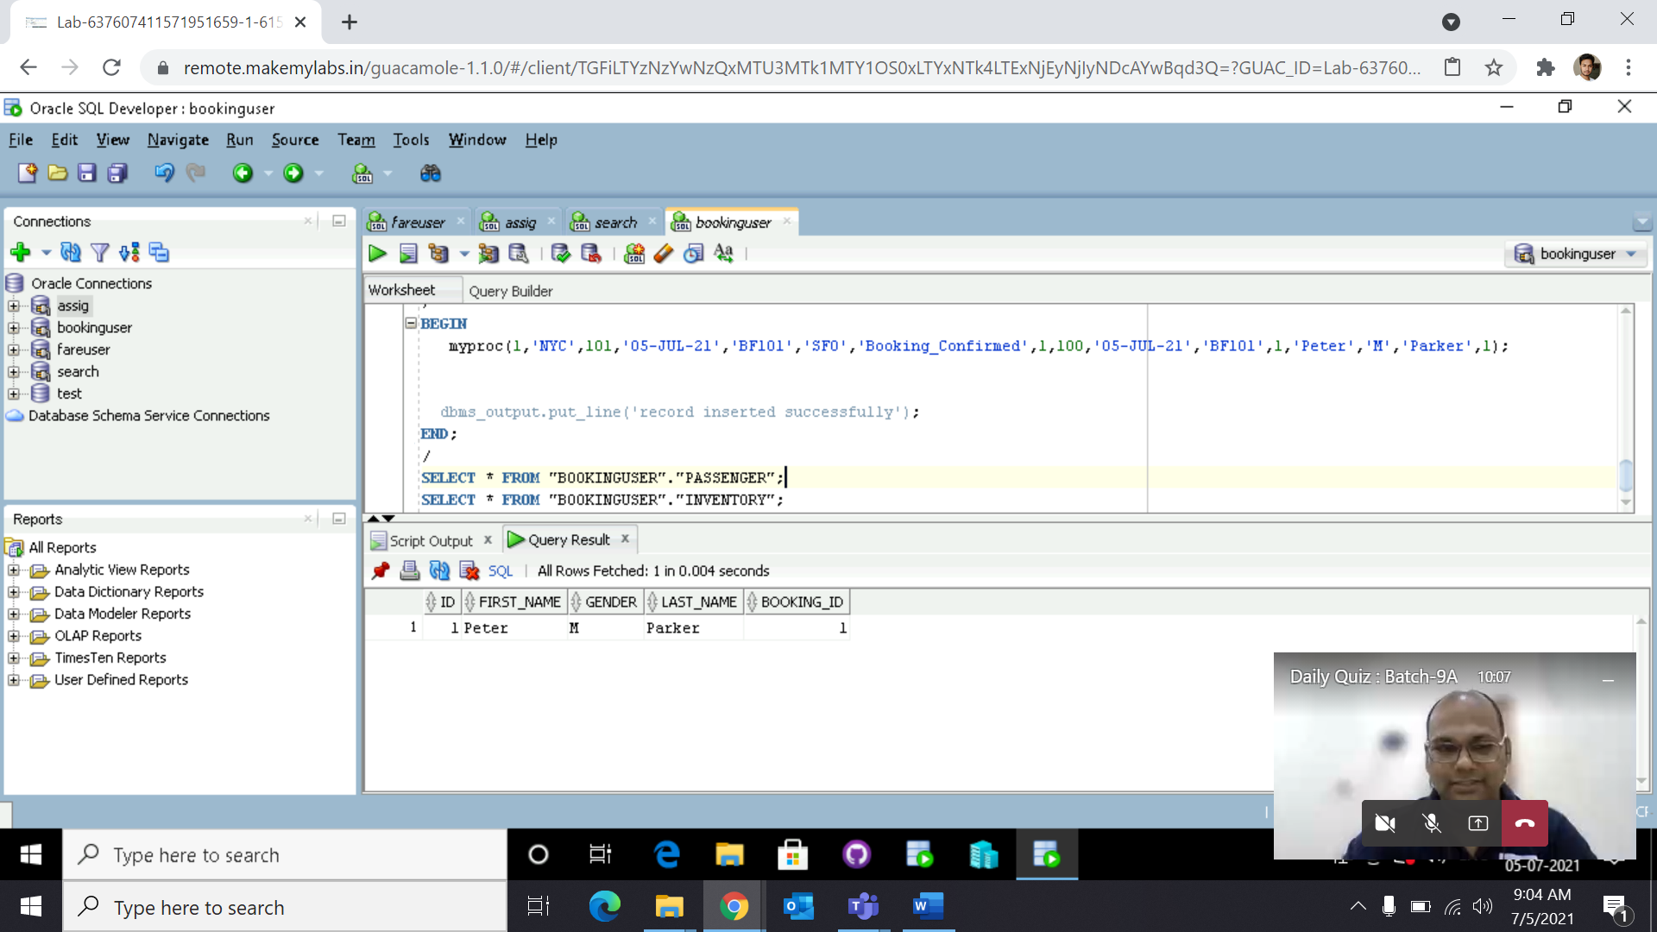

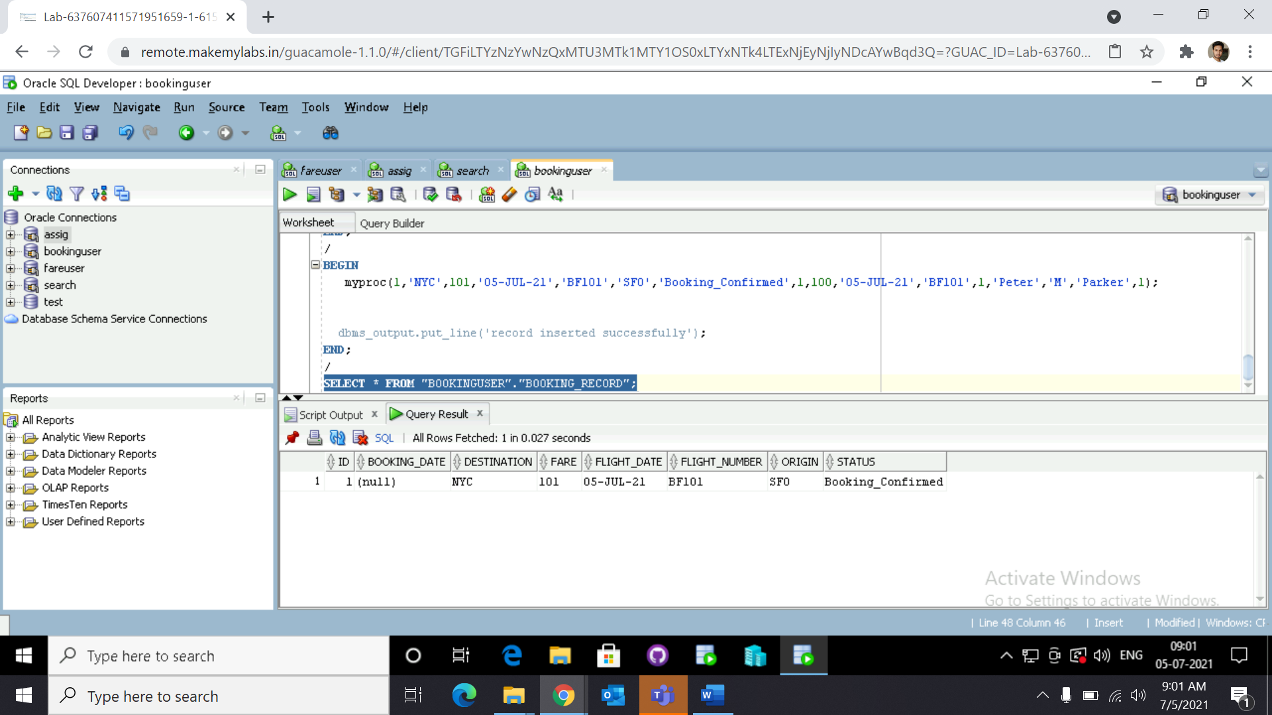

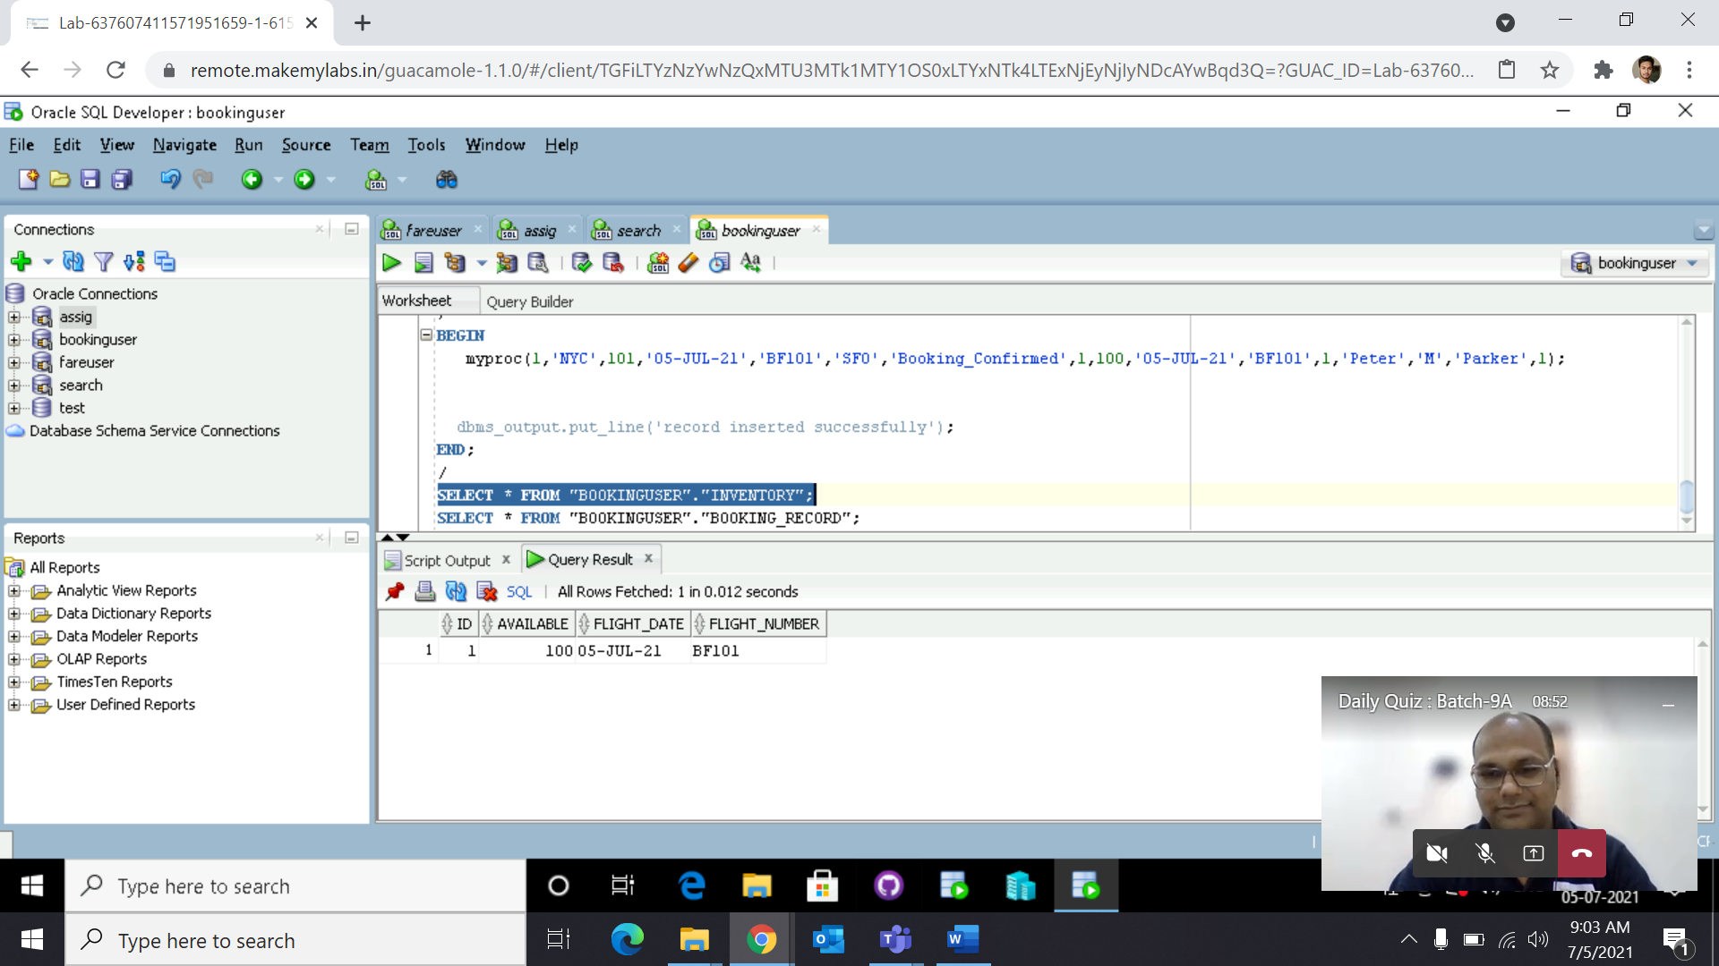

**User Assignment 3**

create sequence checkin_seq start with 1 increment by 1;

create table check_in_record (id

number(19)primary key, booking_id number(19) not

null, check_in_time DATETIME DEFAULT CURRENT_TIMESTAMP, first_name

varchar2(255), flight_date varchar2(255),

flight_number varchar2(255), last_name

varchar2(255), seat_number varchar2(255));

create or replace procedure "INSERT1"

(id in number, booking_id in number, first_name in

varchar2, flight_date in varchar2,

flight_number in varchar2, last_name in

varchar2, seat_number in varchar2)

is

begin

insert into checkin_seq(id, booking_id, first_name, flight_date,

flight_number,last_name,seat_number) values(id, booking_id, first_name, flight_date,

flight_number,last_name,seat_number);

end;

/

**BEGIN**

**insert1(1,101,'Tony','03-Jul-2021','BF101','Stark','28A');**

**dbms_output.put_line('record inserted successfully');**

**END;**

**/**